***PAAREES PERFUMES***

***VERSACE***

***FOR WOMEN***

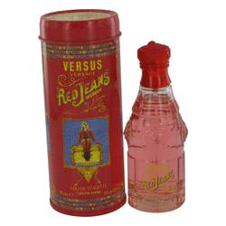

# 

# *Red Jeans*

## *Description:*

Red Jeans by Versace Perfume. Display your distinctive style by wearing Red Jeans for women. Created by the designers at Versace in 1994, this casually elegant fragrance blends the floral notes of jasmine and lily with sandalwood, rich musk and silky vanilla for a laid-back yet indulgent scent you can enjoy anytime, anywhere. Splash some on before heading to the tennis courts on a Saturday afternoon or as you are getting all dolled up for a Saturday evening at the opera.